**Supplemental 1: Data sets**

Buscombe et al. “How good are retrained deep neural networks at classifying images of landscapes?”

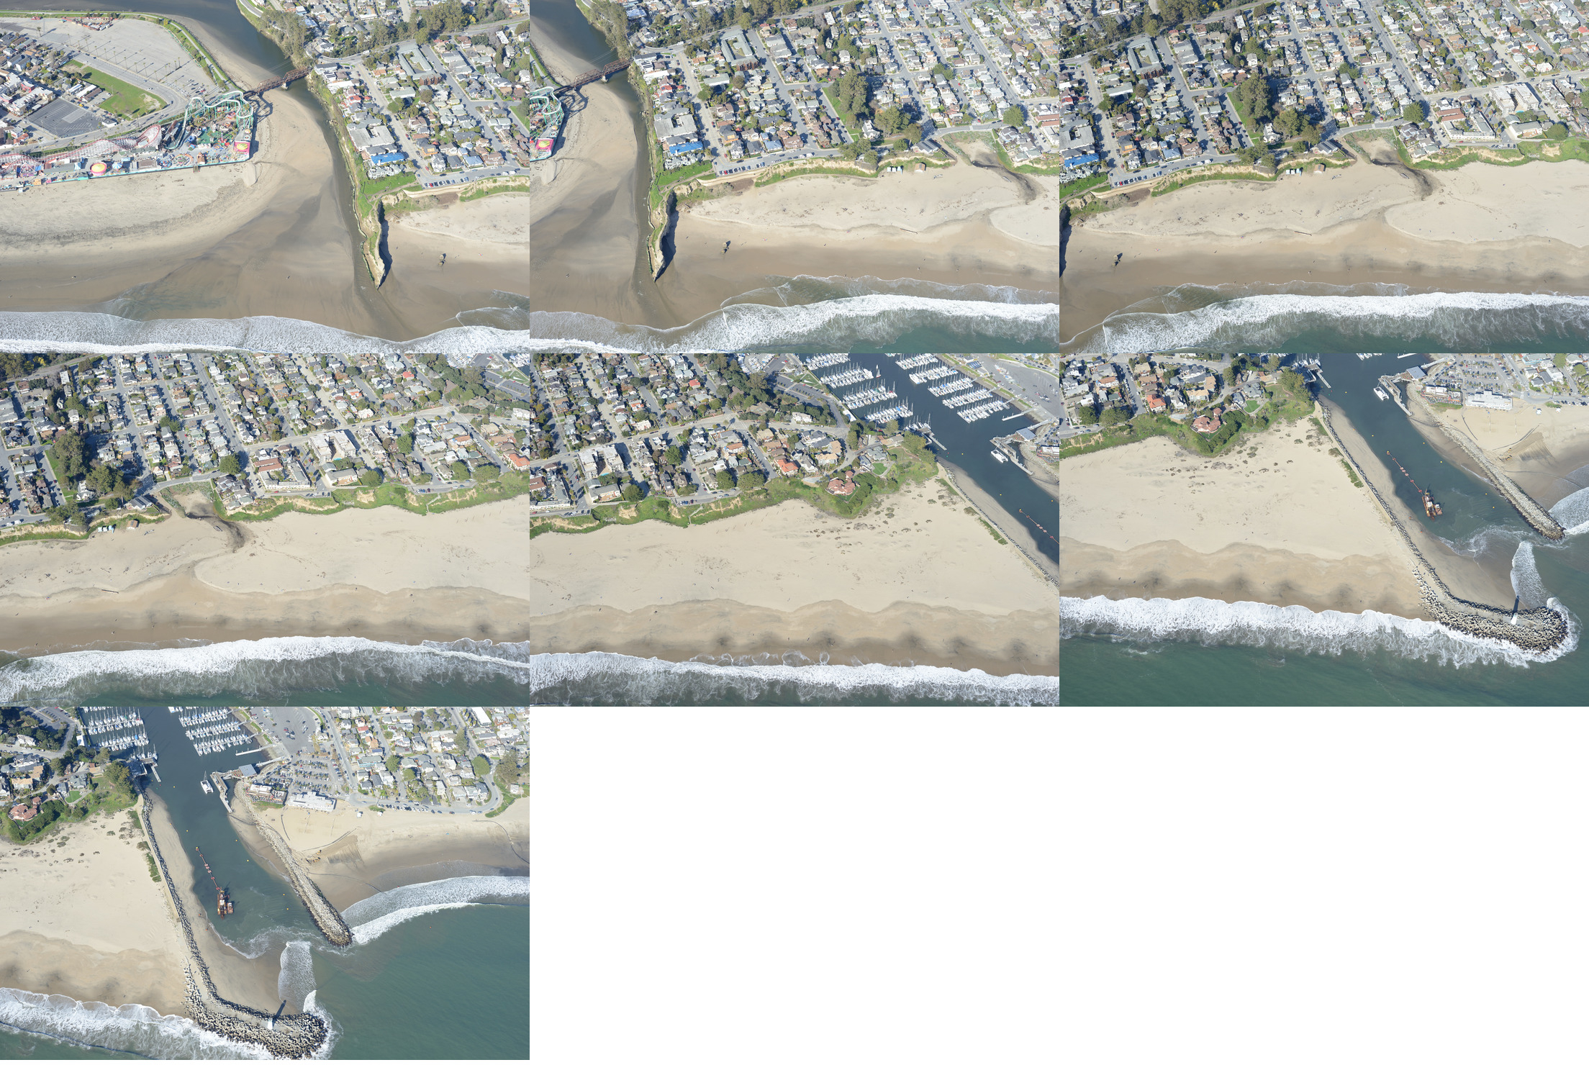

**Figure S1A.** Seabright training images.

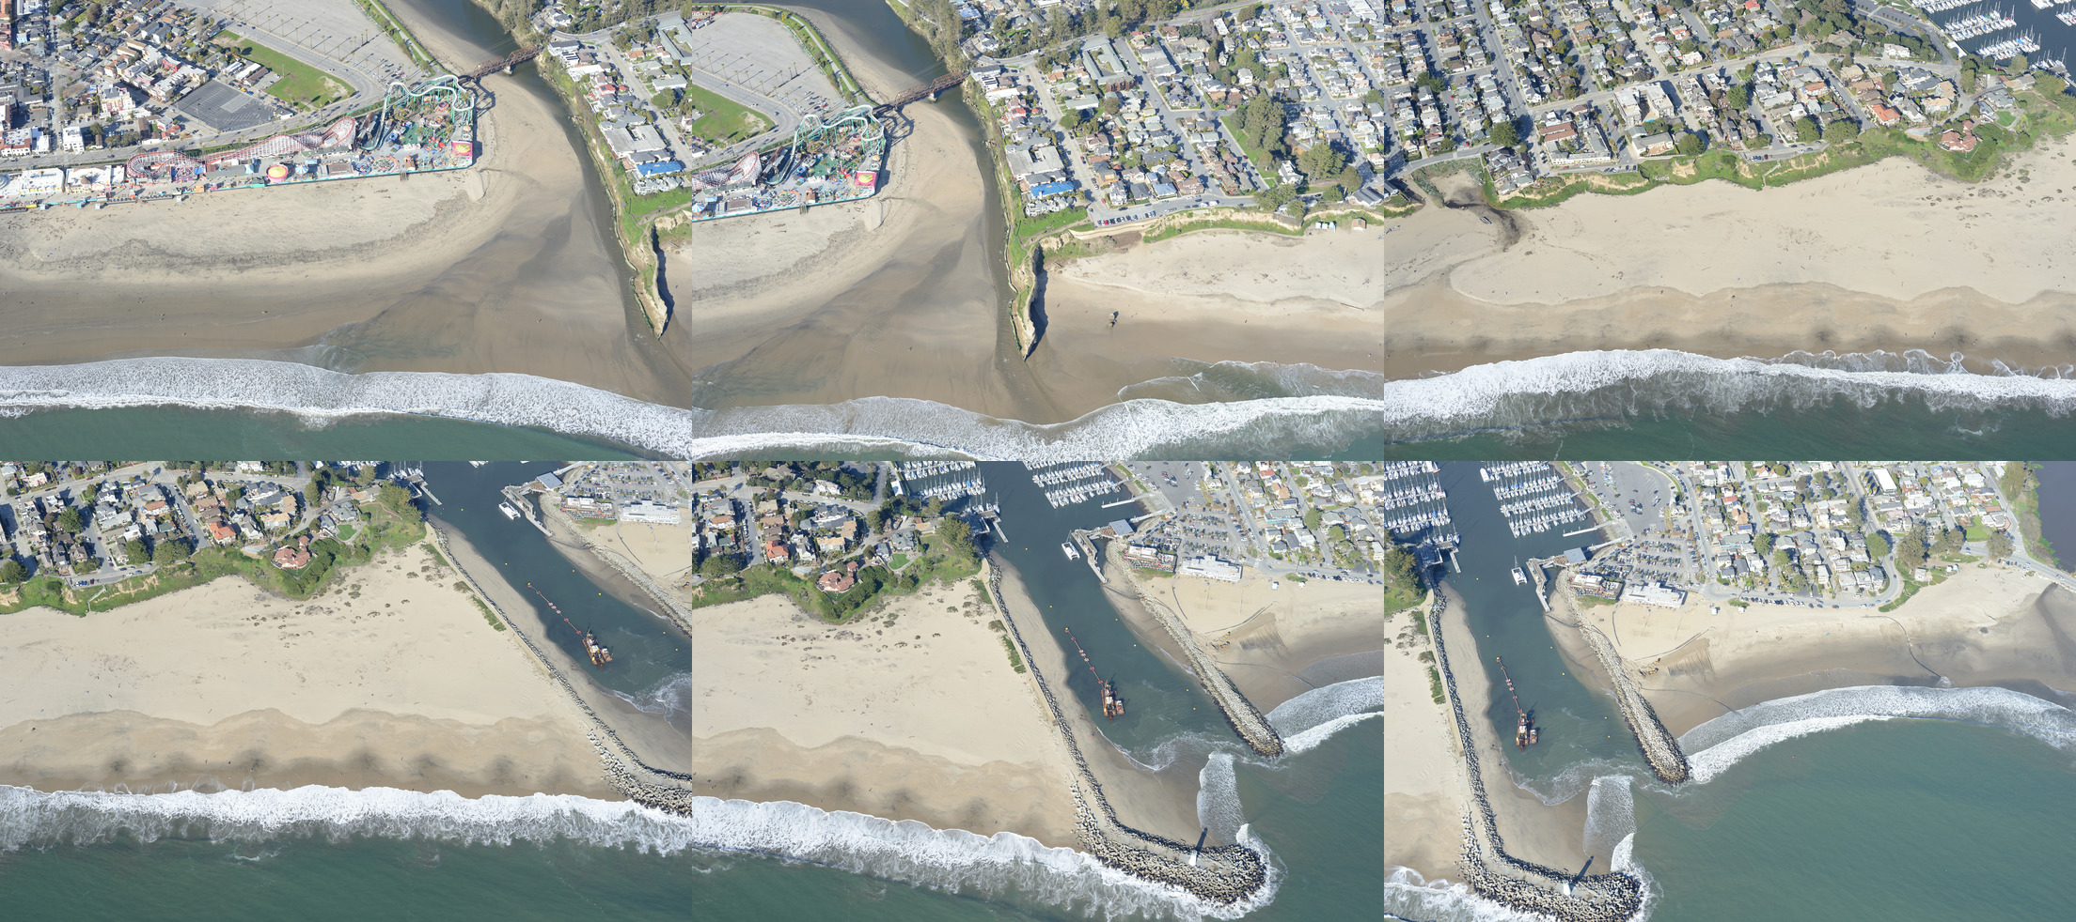

**Figure S1B.** Seabright test images.

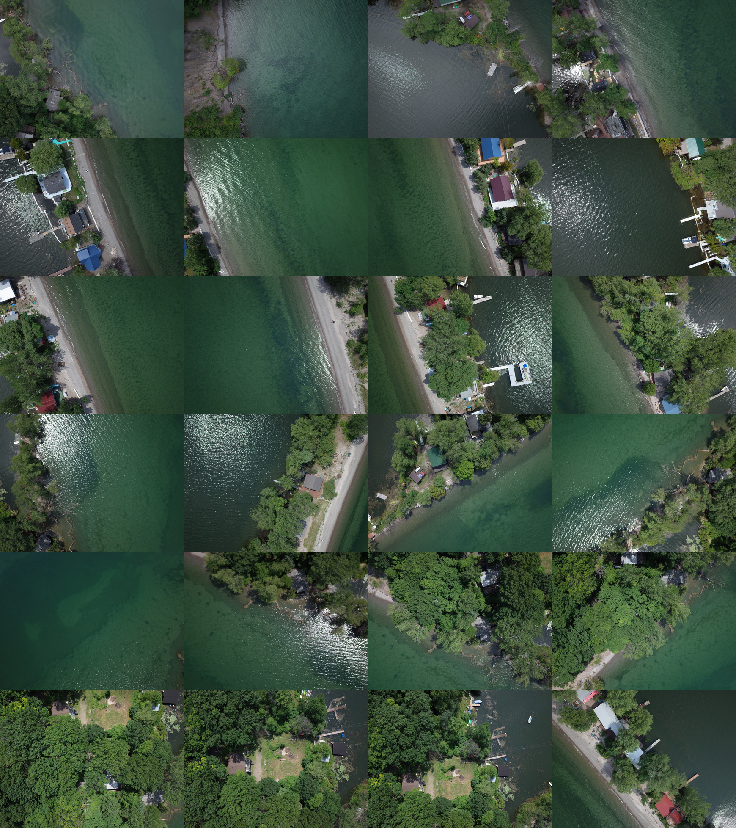

**Figure S1C.** Lake Ontario training images.

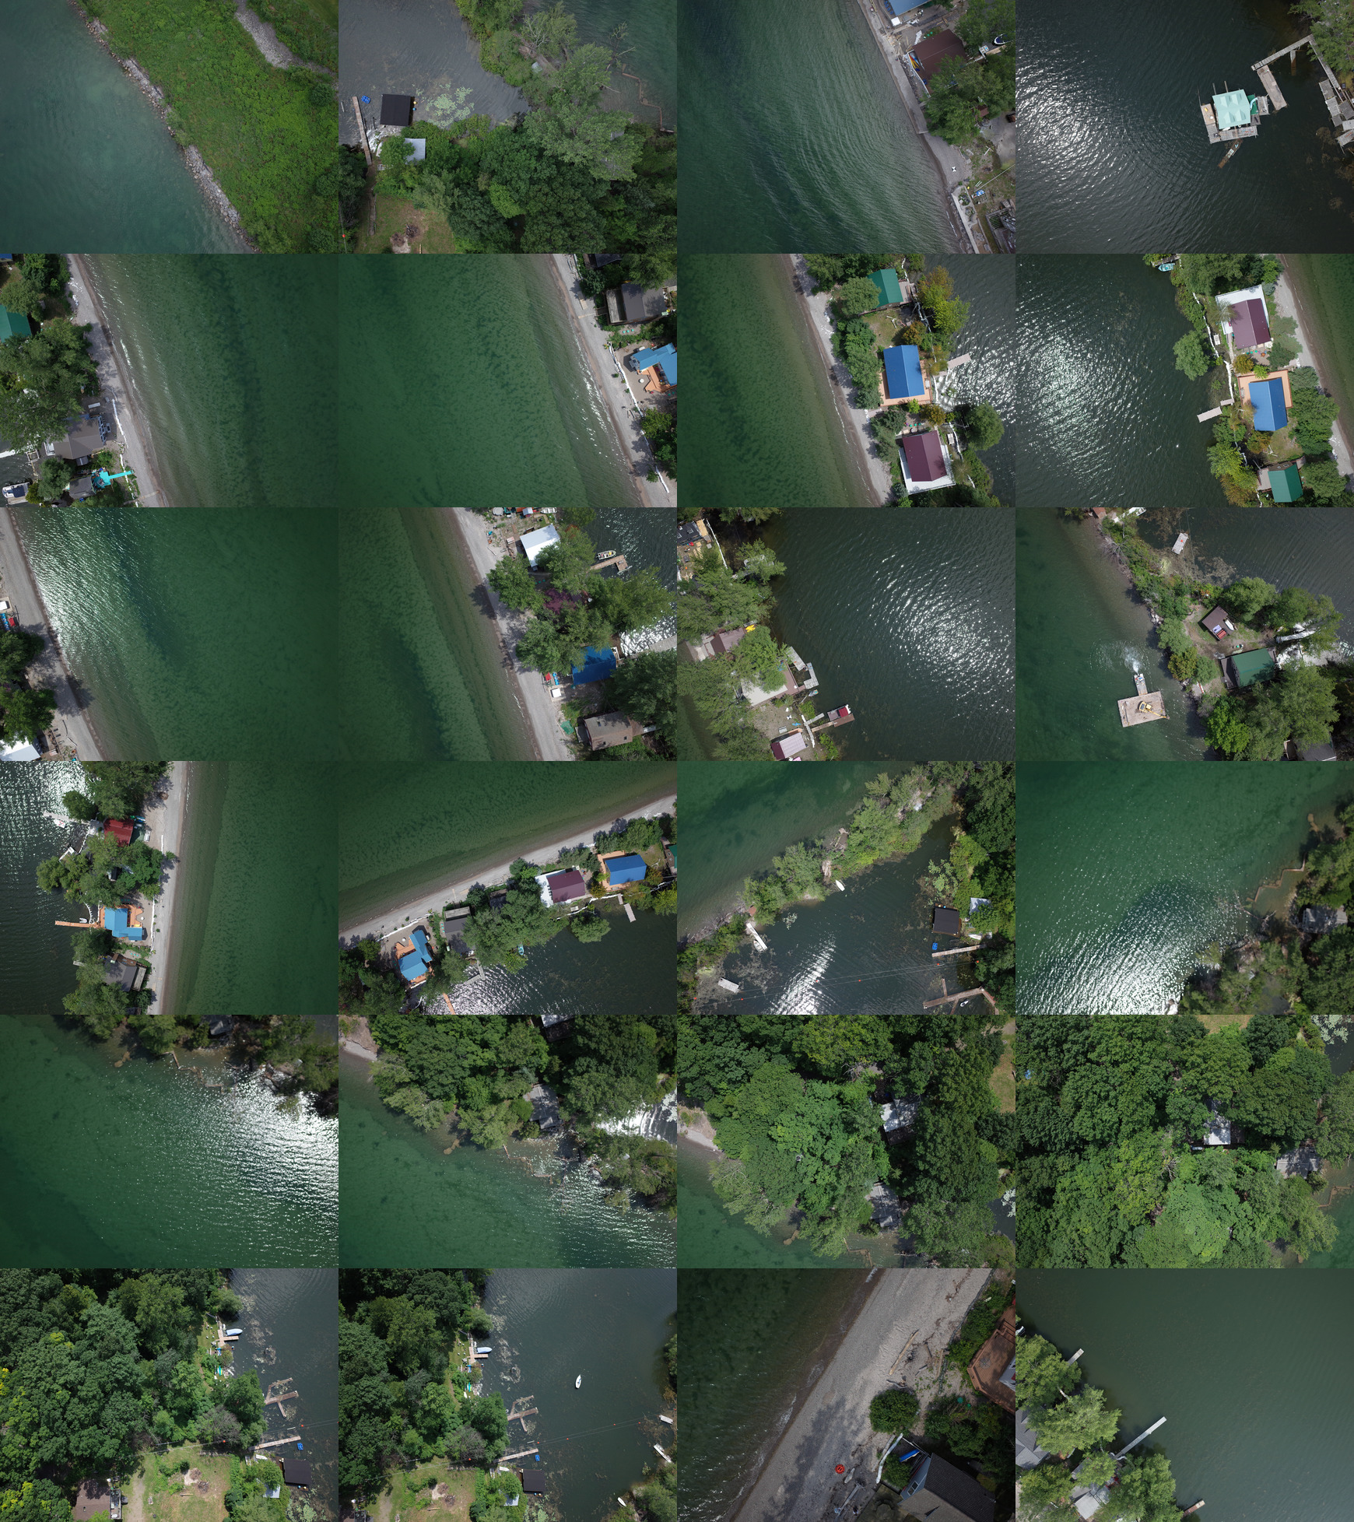

**Figure S1D.** Lake Ontario test images.

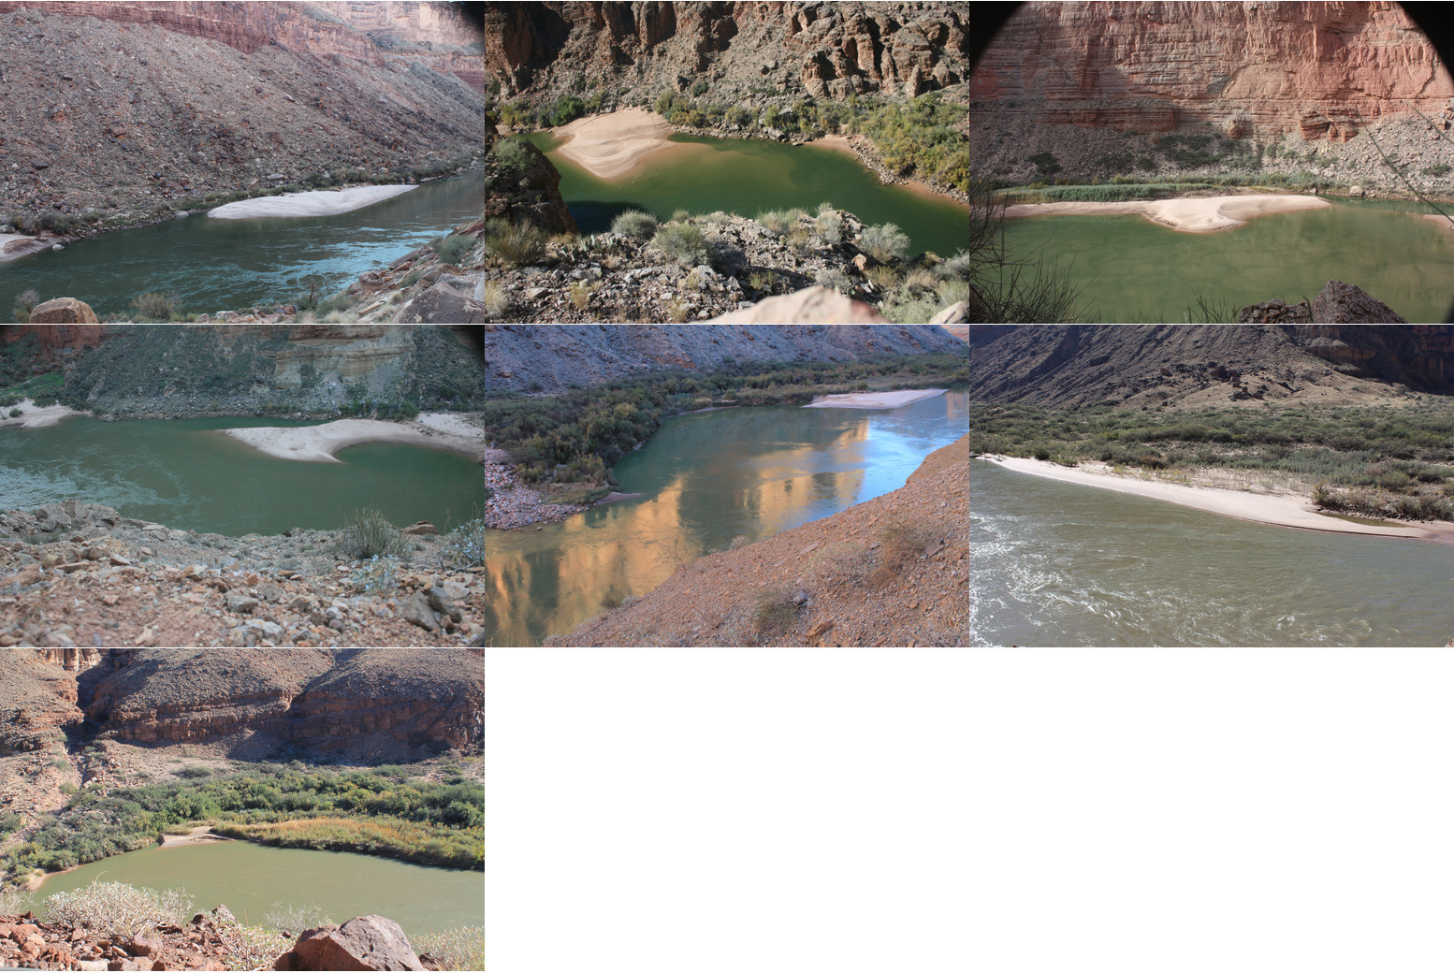

**Figure S1E.** Grand Canyon training images.

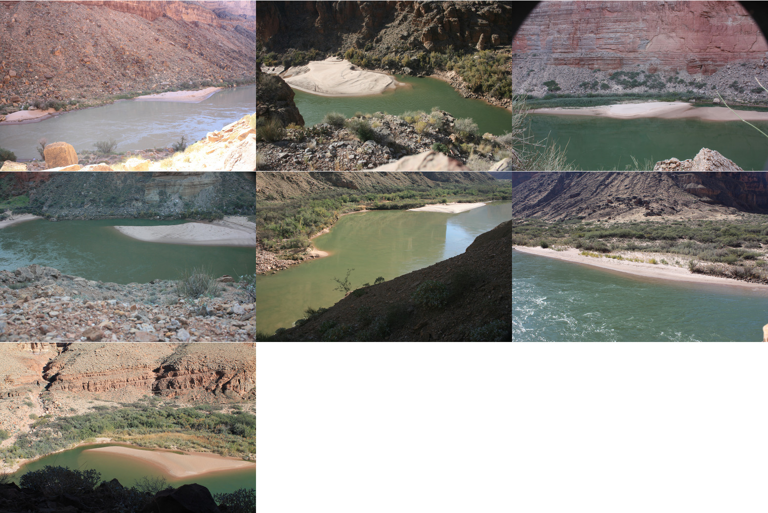

**Figure S1F.** Grand Canyon test images.

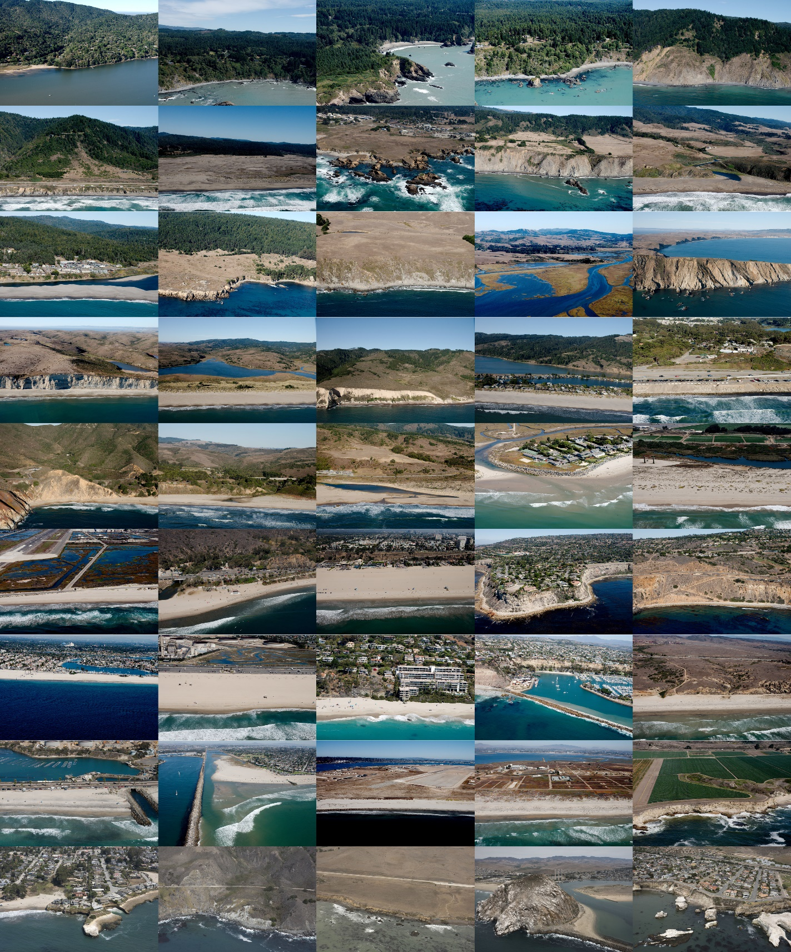

**Figure S1G.** California Coastal Records training images. Copyright (C) 2002-2018 Kenneth & Gabrielle Adelman, [www.Californiacoastline.org](http://www.Californiacoastline.org).

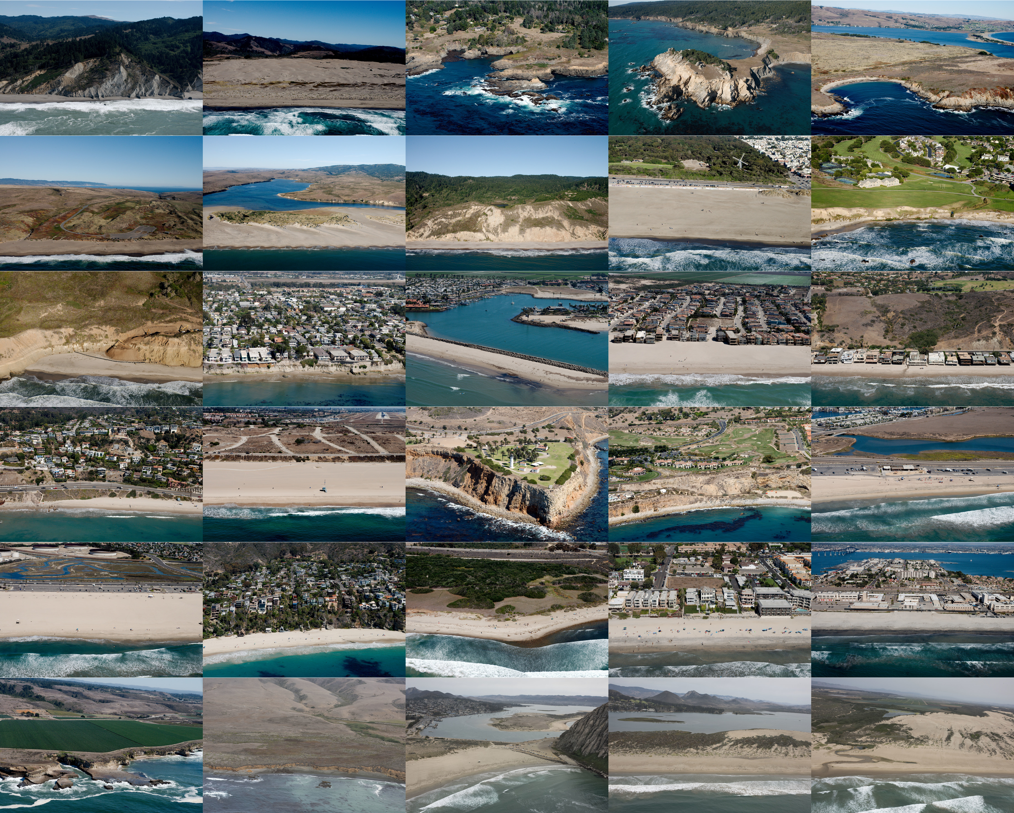

**Figure S1H.** California Coastal Records test images. Copyright (C) 2002-2018 Kenneth & Gabrielle Adelman, www.Californiacoastline.org.